Section I: Scenario Demographics

Scenario Title: | Adrenal Crisis
Date of Development: | 02/03/2015 (DD/MM/YYYY)
Target Learning Group: | Juniors (PGY 1 – 2) Seniors (PGY ≥ 3) All Groups

Section II: Scenario Developers

Scenario Developer(s): | Dr. Kyla Caners
Affiliations/Institution(s): | McMaster University
Contact E-mail (optional): | kcaners@gmail.com

Section III: Curriculum Integration

Learning Goals & Objectives
Educational Goal: | To expose learners to a rare presentation that requires important critical care steps in its management
CRM Objectives: | 1) Communicate clearly with team members during complicated resuscitation.  2) Lead team members effectively through the management of a critically ill patient.
Medical Objectives: | 1) Simultaneously resuscitate and initiate investigations for the critically ill patient with vague symptoms.  2) Recognize non-fluid responsive shock.  3) Recognize and appropriately treat the hyperkalemia and hypoglycemia associated with an adrenal crisis.  4) Initiate appropriate steroid treatment for an adrenal crisis.

Case Summary: Brief Summary of Case Progression and Major Events
A 46-year-old female presents to the ED complaining of fatigue, anorexia, and weight loss over the last two weeks. She had the “stomach flu” a couple weeks ago and thought she was getting over it. But now she feels very weak and seems to be vomiting again. On presentation, the patient will have mild hypothermia, hypoglycemia, and hypotension. The team will have to initiate fluid resuscitation and an initial workup. The patient’s blood pressure won’t respond to 4 L of IV fluids, forcing the residents to work through the differential diagnosis of shock. Eventually, they will receive critical VBG results that indicate a mild metabolic acidosis, hyperkalemia, and hyponatremia. The team will need to treat the hyperkalemia and initiate hydrocortisone therapy.

References
Sharma A, Levy D. (2013). Thyroid and adrenal disorders. In J. Marx, R. Hockberger & R. Walls (Eds.), Rosen's emergeny medicine - concepts and clinical practice. pp. (1689-92). Philadelphia, PA.:Saunders.

Section IV: Scenario Script

A. Scenario Cast & Realism
Patient: | Computerized Mannequin |  |  |  |  | Realism:  Select most important dimension(s) |  |  | Conceptual
 | Mannequin |  |  |  |  |  |  |  | Physical
 | Standardized Patient |  |  |  |  |  |  |  | Emotional/Experiential
 | Hybrid |  |  |  |  |  |  |  | Other:
 | Task Trainer |  |  |  |  |  |  |  | N/A
Confederates | Brief Description of Role
None.
B. Required Monitors
EKG Leads/Wires |  |  | Temperature Probe |  |  |  | Central Venous Line
NIBP Cuff |  |  | Defibrillator Pads |  |  |  | Capnography
Pulse Oximeter |  |  | Arterial Line |  |  |  | Other:
C. Required Equipment
Gloves |  |  | Nasal Prongs |  |  |  | Scalpel
Stethoscope |  |  | Venturi Mask |  |  |  | Tube Thoracostomy Kit
Defibrillator |  |  | Non-Rebreather Mask |  |  |  | Cricothyroidotomy Kit
IV Bags/Lines |  |  | Bag Valve Mask |  |  |  | Thoracotomy Kit
IV Push Medications |  |  | Laryngoscope |  |  |  | Central Line Kit
PO Tabs |  |  | Video Assisted Laryngoscope |  |  |  | Arterial Line Kit
Blood Products |  |  | ET Tubes |  |  |  | Other:
Intraosseous Set-up |  |  | LMA |  |  |  | Other:
D. Moulage
None required.

E. Approximate Timing
Set-Up: |  | 5 min |  | Scenario: | 15 min |  |  | Debriefing: |  | 20 min

Section V: Patient Data and Baseline State

A. Clinical Vignette: to Read Aloud at Beginning of Case
A 46-year-old female presents to the ED complaining of fatigue, anorexia, and weight loss over the last two weeks. She had the “stomach flu” a couple weeks ago and thought she was getting over it. But now she feels very weak and seems to be vomiting again. Her blood pressure is 80/40, so she was triaged straight to the resuscitation bay.
B. Patient Profile and History
Patient Name: Andrea Nealy |  |  |  |  |  | Age: 42 |  |  |  |  |  |  |  | Weight: 65 kg
Gender: M F |  |  |  |  |  | Code Status: Full
Chief Complaint: Vomiting
History of Presenting Illness: Had “stomach flu” two weeks ago. Thought she was getting better. But now, over the last few days, feeling weak, tired, and starting to vomit again.
Past Medical History: |  | Depression |  |  |  |  | Medications: |  |  |  |  | Celexa 20mg OD
Allergies: None.
Social History: Single mother of two (ages 10 and 12). Smokes ½ ppd. Occasional EtOH. No recreational drugs.
Family History: Nil.
Review of Systems: |  | CNS: |  |  | Feels tired and weak.
 |  | HEENT: |  |  | Nil.
 |  | CVS: |  |  | Nil.
 |  | RESP: |  |  | Nil.
 |  | GI: |  |  | Progressively vomiting more and more. No blood. No bile. Unable to maintain PO. No diarrhea. Minimal abdo pain.
 |  | GU: |  |  | No lower urinary tract symptoms.
 |  | MSK: |  |  | Nil. |  |  |  |  |  |  |  | INT: |  | Feels really chilled.
B. Baseline Simulator State and Physical Exam
No Monitor Display |  |  |  | Monitor On, no data displayed |  |  |  |  |  |  | Monitor on Standard Display
HR: 125/min |  |  | BP: 80/40 |  |  |  |  | RR:18/min |  |  |  |  |  |  | O₂SAT: 98 % RA
T: 35ºC |  |  | Glucose: 2.6 mmol/L
General Status: Appears unwell. Looks pale and dehydrated.
CNS: | PERLA, 2-3mm. A+Ox3, answering questions. No focal deficits.
HEENT: | Nil acute.
CVS: | Normal HS, no murmurs. Weak peripheral pulses.
RESP: | GAEB. No adventitious.
ABDO: | Soft, non-tender.
GU: | Nil acute.
MSK: | No hot joints. |  |  |  |  |  |  |  | SKIN: | Pale. No rashes.

Scenario States, Modifiers and Progression
Patient State | Patient Status | Learner Actions, Modifiers & Triggers to Move to Next State
1. Baseline State  Rhythm: sinus tach  HR: 125/min  BP: 80/40  RR: 18/min  O₂SAT: 98 % RA  T: 35ºC | A+Ox3.  Looks pale, dehydrated, unwell. | Learner Actions  - Monitors  - IV access, bolus 2L  - Order septic work-up, liver panel, VBG, lactate (broad)  - Order urine or serum βHCG  - Check sugar, give glucose  - Administer antibiotics  - Order CXR  - Order urinalysis  - Start vasopressors after IVF don’t correct BP  - Bedside U/S to assess for FF or PCE | Modifiers  - Give 2L bolus HR 115  - Give 4L bolus HR 110  - No blood work ordered by 5 min frequent PVC’s  Triggers  - Fluids given, blood work ordered, glucose corrected, or 10 min. 2. Blood work back  - Capillary glucose not checked by 5 min. 3. Seizure
2. Blood work back  HR 110  BP 85/40 | Clinically less dry. Still looks unwell. | Learner Actions  - ID hyperkalemia, do ECG  - Treat hyperkalemia:  1) Calcium gluconate 1g iv  2) D50 + 10 units insulin R  3) Ventolin 16 puffs  4) NaHCO3 1 amp  - ID hyponatremia and treat slowly  - ID adrenal crisis as most likely diagnosis, treat with hydrocortisone 100mg iv | Modifiers  - Give hydrocortisone BP to 100/60  Triggers  - Don’t recognize adrenal crisis by 12 min. 4. VF arrest  - Don’t treat hyperkalemia by 12 min. 4. VF arrest  - Correct potassium and give hydrocortisone End Case
3. Seizure  HR 140  BP unable  RR no effort  O₂SAT 90% despite FiO2 | Patient having tonic clonic seizures. | Learner Actions  - Check blood glucose  - Correct glucose with D50 | Modifiers  - Patient will keep seizing until glucose given.  Triggers  - Glucose given 2. Blood work back  - Intubation without glucose check 4. VF arrest
4. VF arrest  Rhythm VF  HR 180, no pulse  BP unable | Patient pulseless with VF rhythm x3 rounds. | Learner Actions  - Good quality CPR  - Shock VF  - Epinephrine  - Amiodarone  - ±Intubation | Triggers  - 15 min End Case
Section VI: Scenario Progression

Section VII: Supporting Documents, Laboratory Results, & Multimedia

Laboratory Results
Na: 120 | K: 7.5 |  |  | Cl: 100 |  | HCO₃: 17 |  | BUN: 10 |  | Cr: 35 |  |  | Glu: 1.5
VBG |  | pH: 7.31 |  |  | PCO₂: 32 |  | PO₂: 45 |  | HCO₃: 18 |  |  | Lactate: 3.1
WBC: 18.5 |  |  | Hg: 140 |  |  |  | Hct: 0.66 |  |  |  | Plt: 550

Images (ECGs, CXRs, etc.)
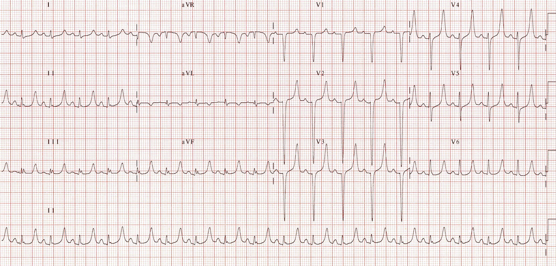
ECG source: http://lifeinthefastlane.com/ecg-library/basics/hyperkalaemia/
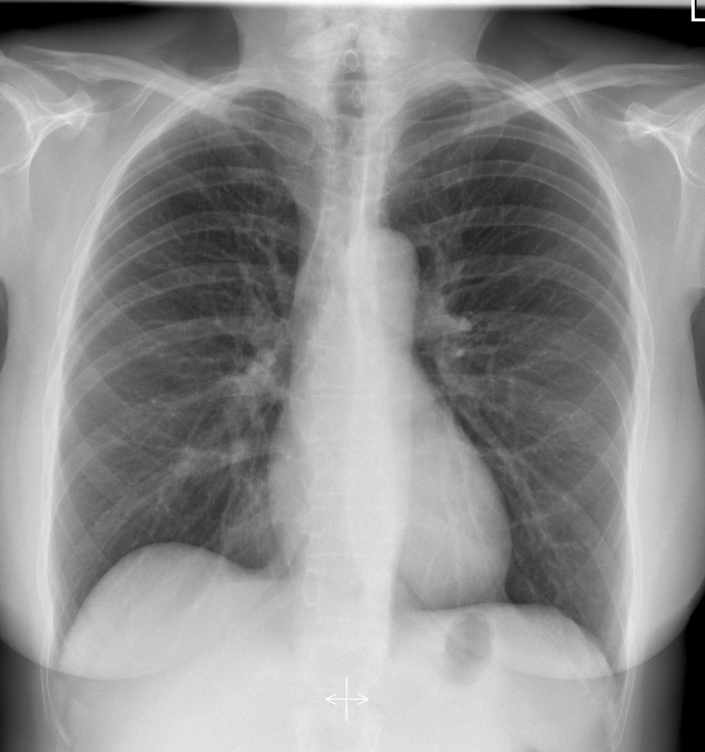
CXR source: https://radiopaedia.org/cases/normal-chest-radiograph-female-1
Ultrasound Video Files (if applicable)
Cardiac Ultrasound – no PCE
FAST – no free fluid
Section VIII: Debriefing Guide

General Debriefing Plan
Individual | Group |  | With Video | Without Video
Objectives
Educational Goal: |  | To expose learners to a rare presentation that requires important critical care steps in its management
CRM Objectives: |  | 1) Communicate clearly with team members during complicated resuscitation.  2) Lead team members effectively through the management of a critically ill patient.
Medical Objectives: |  | 1) Simultaneously resuscitate and initiate investigations for the critically ill patient with vague symptoms.  2) Recognize non-fluid responsive shock.  3) Recognize and appropriately treat the hyperkalemia and hypoglycemia associated with an adrenal crisis.  4) Initiate appropriate steroid treatment for an adrenal crisis.
Sample Questions for Debriefing
- What was your original differential diagnosis for this critically ill patient? How did that change throughout the case? What acted as a trigger to your thought process? Did it feel uncomfortable to change your working diagnosis?
- Did you find it challenging to trouble-shoot this patient’s refractory shock? How do you feel to worked to problem-solve this as a team?
- What are the laboratory abnormalities associated with a primary adrenal crisis? How are they different in secondary adrenal failure? Why?
- Why is hydrocortisone the steroid used for treatment in acute adrenal crisis? What are other options?
Key Moments
1) Recognition that the patient is critically ill and not responding to IVF.
2) Identification and treatment of hypoglycemia.
3) Identification of possible adrenal crisis.

